April 2015
RE: Internship Program

Dear Possible Intern

Thank you for your interest in the Chiefs FC Internship Program. Below you will find the breakdown of basic conditions and program structure.

Team/Group | Compensation per month | Number of Months | Expected number of players in group
Academy Intern Coach | Coaching education | 8 | N/A

The Internship Program is designed to educate coaches in the Chiefs Way coaching philosophy and provide the coach on field experience. Chiefs FC will pay for all coaching education during the seasonal year as outlined above as long as the program is completed by the candidate.

Basic Conditions
- Contract length will run from the first day of Tryouts 2015 until the end of the Spring 2016 Season
- Coaches will follow the Chiefs Way curriculum as set by the club, will dress in Chiefs FC attire and always have practices plans prepared in advance of practice.
- Groups will practice a minimum of twice per week, practices will run for 90 minutes and coaches will be expected to be present at the fields 20 minute prior to practice time and 10 minutes after practice concludes or until all players have been collected by parents. Unless otherwise stated, practices do not get canceled unless Chiefs FC closes the fields.
- Coaches will arrive in a timely manner on game dates and unless coming from another Chiefs FC event will plan to be at the fields 30 minutes prior to kick off for U9-U10, 45 minutes for U11-U13 and 1 hour for U14-U19. If the intern is assigned to games they will be compensated for their time.
- Coaches must give 2 weeks’ notice of any absences. Any emergency situations must be communicated ASAP.
- Coaches will be allowed up to a total of 3 practice absences and/or 2 game date absences for the fall and for the spring season.
- Over the year, Coaches will be allowed one absence from all other Chiefs FC functions, that include Tryouts (3-6 nights), Chiefs FC Coaches clinics (2-3 per season), Signing Days (1-2 evenings) and Formal Chiefs FC Club Meetings (1-2 per year). Some functions coaches will not be required to be in attendance for the entire event but an appearance will be required.
- All team communication and administrative duties must be performed in a timely manner. Any/all concerns, conflicts, questions or parent issues must be reported to the Chiefs FC administration.
To be considered for our internship program please submit your resume to me at the email address listed below. Thank you again for your interest in the Chiefs FC Internship Program.

Regards,
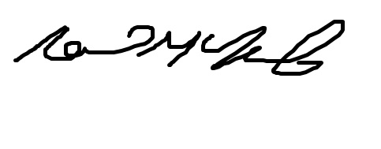
Neil McNab Jr
Chiefs FC Program Director
neiljr@chiefsfc.org

